Project Report: Robot Navigation in a Random Maze using A Algorithm*

- Introduction
Navigating through a maze is a timeless challenge in the fields of robotics and artificial intelligence. Here, an agent is tasked with finding the best route from a starting point to a destination while steering clear of obstacles. In this project, we employ the A* (A-Star) pathfinding algorithm to guide a robot through a randomly generated maze. Each time the program runs, the size of the maze and the placement of obstacles are randomized, creating a fresh and unpredictable environment for the robot to explore. Rest assured, the program ensures that a valid path is available before presenting the final result.

- Objective
Our goal is to create a smart navigation strategy for a robot to navigate through a maze. We aim to generate random mazes with varying dimensions and obstacles. We will use the A* pathfinding algorithm to determine the shortest route from the starting point to the endpoint. Finally, we’ll visualize the maze and the calculated path using Matplotlib in Google Colab.
- Methodology
- Tools & Technologies
Python: Programming language for implementing logic.
NumPy: For maze creation and grid operations.
Heapq: For implementing the A* algorithm priority queue.
Matplotlib: For visualizing the maze and the path.
- Steps Followed
Random Maze Generation
Dimensions randomly selected between 5×5 and 10×10.
Cells filled randomly with 0 (walkable) and 1 (obstacle).
Start (0, 0) and End (rows-1, cols-1) always walkable.
- A Algorithm Implementation*
Uses Manhattan Distance as the heuristic function.
Explores possible paths while prioritizing cells with the lowest estimated cost.
Stores parent relationships to reconstruct the final path.
- Validation Loop
Keeps generating mazes until a valid path is found.
- Visualization
The maze grid is displayed with:
White cells = walkable paths
Black cells = obstacles
Cyan = computed path
Green circle = start
Red X = end
- Code and implementation details
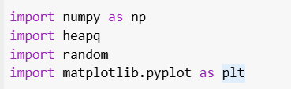
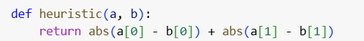
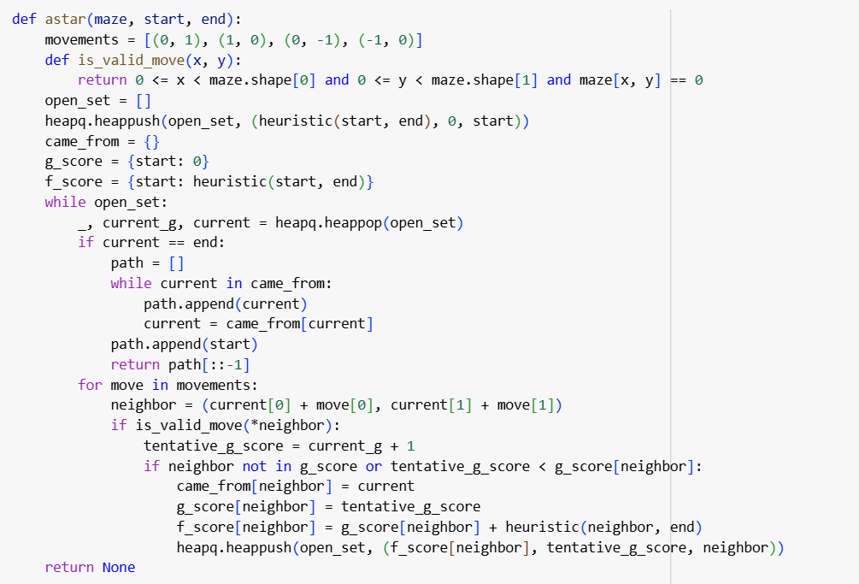
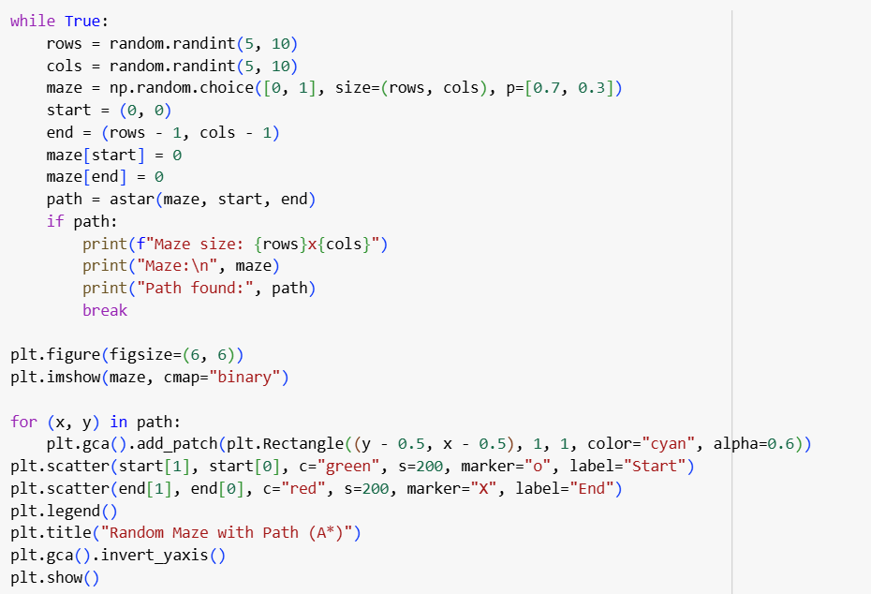

- Results and Observations
The algorithm does a great job of finding the shortest path through randomly generated mazes. The varying sizes and placements of obstacles make the navigation challenge feel more realistic and engaging. The visualization effectively highlights the route from the starting point to the finish, even in the most intricate mazes.
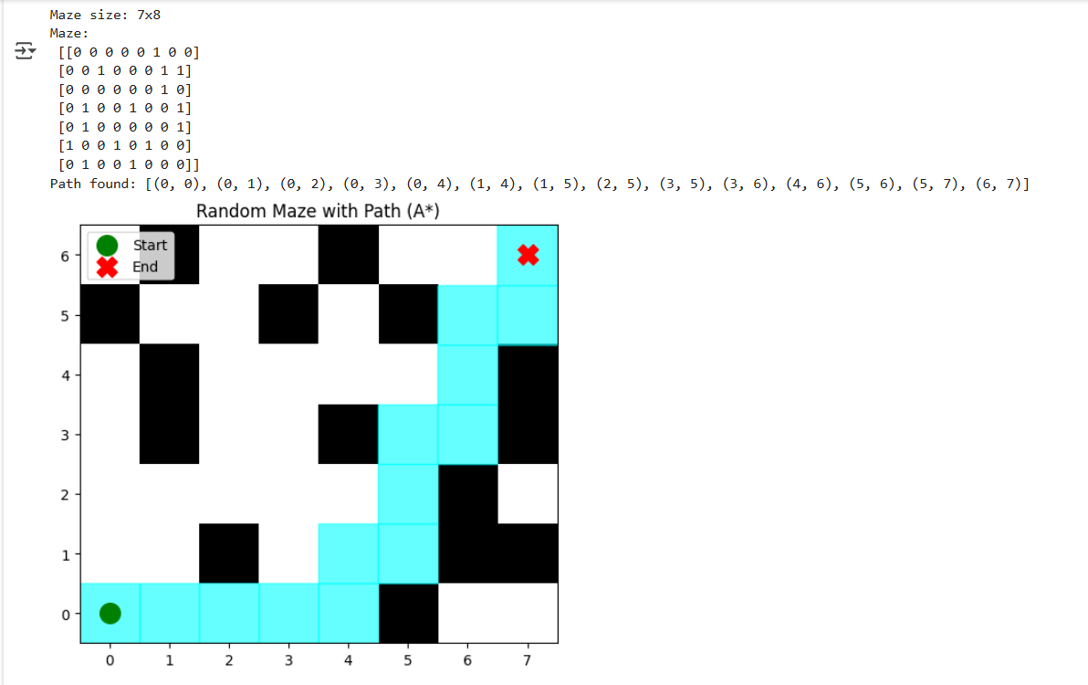

- Conclusion
This project showcases how the A* pathfinding algorithm can effectively guide robots through dynamic environments. By varying the sizes of mazes and the placement of obstacles, we put the navigation strategy to the test under different scenarios. The findings reveal that A* is quite adept at identifying the best path while skillfully dodging obstacles, making it a great fit for real-world autonomous navigation challenges.
Key Learnings: -
Using the A* algorithm with a heuristic boosts pathfinding efficiency.
Generating random environments helps ensure the solution's robustness.
Visualization significantly improves our grasp of how the algorithm operates.

